***Intro to Python Overview of Code***

***Section 1:***

- Inputs, If else, Sums, Print()

total_msrp = 0

total_cost = 0

total_potential_gross_profit = 0

total_adjusted_gross_profit = 0

** We are creating a value for these amount while using an input**

print("Enter details for car #1:")

car_name1 = input("Car name 1 (e.g., Red 1969 Triumph TR6): ")

msrp1 = int(input("MSRP: "))

cost1 = int(input("Cost: "))

print("Type (0=domestic, 1=import): ")

car_type_code1 = int(input())

** Creating an placeholder for the input

- creating an input()

- We are then stating it is an integer to create a number**

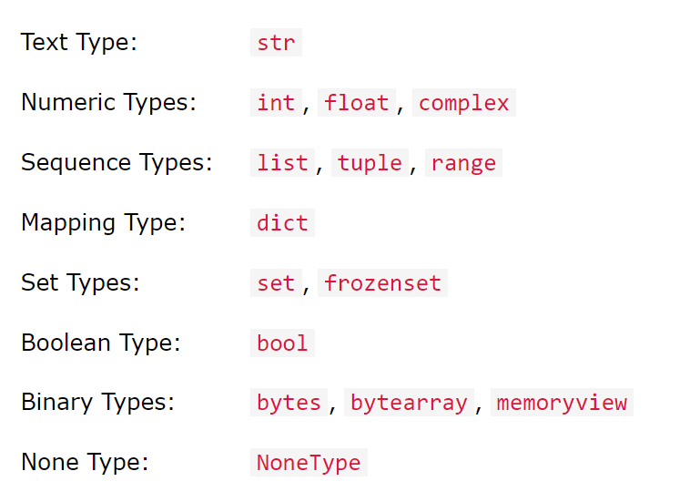

#Determine car type

car_type1 = "domestic" if car_type_code1 == 0 else "import"

** This involves identifying the to use domestic or import using and if else statement**

#Calculate gross profit and adjusted gross profit

gross_profit1 = msrp1 - cost1

adjusted_gross_profit1 = gross_profit1 * (0.9825 if car_type_code1 == 1 else 1)

** Creating new variables that will calculate the information from the inputs that were collected**

#Totals for all cars

total_cost = sum([cost1, cost2, cost3, cost4, cost5])

total_msrp = sum([msrp1, msrp2, msrp3, msrp4, msrp5])

total_potential_gross_profit = sum([gross_profit1, gross_profit2, gross_profit3, gross_profit4, gross_profit5])

total_adjusted_gross_profit = sum([adjusted_gross_profit1, adjusted_gross_profit2, adjusted_gross_profit3, adjusted_gross_profit4, adjusted_gross_profit5])

** This was to create a sum at the end without using a loop**

#Totals Car 1

print("Details for Car 1:")

print("Car Name:", car_name1)

print("MSRP:", msrp1)

print("Cost:", cost1)

print("Potential Gross Profit:", gross_profit1)

print("Adjusted Gross Profit:", adjusted_gross_profit1)

#Total

print("Totals for the shipment:")

print("Total MSRP:", total_msrp)

print("Total Cost:", total_cost)

print("Total Potential Gross Profit:", total_potential_gross_profit)

print("Total Adjusted Gross Profit:", total_adjusted_gross_profit)

** Showcasing the print from car one. This includes the key and the information from the input that was collected**

**Section 2**

Functions, If else within a function, While loop, float, and f string

#Called function to determine user's monthly payment based on credit score

def monthly_payment_percentage (passedCreditScore, passedMonthlyGrossIncome):

if int(passedCreditScore) < 530:

#15% of gross monthly income

monthly_payment = float(passedMonthlyGrossIncome) * float(0.15)

elif int(passedCreditScore) < 590:

#15% of gross monthly income

monthly_payment = float(passedMonthlyGrossIncome) * float(0.15)

elif int(passedCreditScore) < 640:

#17% of gross monthly income

monthly_payment = float(passedMonthlyGrossIncome) * float(0.17)

elif int(passedCreditScore) < 721:

#20% of gross monthly income

monthly_payment = float(passedMonthlyGrossIncome) * float(0.20)

else:

#30% of gross monthly income

monthly_payment = float(passedMonthlyGrossIncome) * float(0.30)

return str(monthly_payment)

** The function name is Monthly_payment_percentage

- (passedCreditScore, passedMonthlyGrossIncome) = parameters used to create the function

- if int(passedCreditScore) < 530 = stored as int for passedcreditscore

- monthly_payment = float(passedMonthlyGrossIncome) * float(0.20) =

*monthly_payment:* This is a variable where the calculated monthly payment amount is stored.

*float(passedMonthlyGrossIncome):* This converts the passedMonthlyGrossIncome parameter to a floating-point number. It's assumed that passedMonthlyGrossIncome is either a string that represents a number or an integer that needs to be converted to a float for decimal accuracy in calculations.

*float(0.30):* This represents the percentage (30%) as a floating-point number. Multiplying the gross monthly income by 0.30 calculates 30% of the income.

## *The float()* function in Python is used to convert a given value into a floating-point number. A floating-point number is a way to represent real numbers within a certain degree of precision that can include a fractional part, such as 3.14, -0.001, or 2.0. This function is versatile and can handle various types of input:

## *numbers that have a fractional component. float can handle decimal points (e.g., 3.14, -0.001), while int is limited to whole numbers (e.g., 3, -1).\*\*\**

##return str(monthly_payment)

** str() Function: The str() function in Python converts the argument passed into it into a string type. When str() is applied to a floating-point number, it creates a textual representation of that number. For example, if monthly_payment were 123.45, str(monthly_payment) would convert it to the string "123.45".

return: This keyword is used to exit the function, sending back a value to the place where the function was called. In this case, the function returns the string representation of monthly_payment.***